USER INTERFACE AND DESIGN

EXPERIMENT – 8

Roll No:240701529

Aim:
The aim is to create storyboards representing the user flow for a mobile E-commerce application, including categorized browsing, using Balsamiq.

Procedure

- Tool Used: Balsamiq Wireframes (https://balsamiq.com)
- Project Creation: I started a new mobile project and utilized the "Hand-drawn" skin to focus on the structural layout and user logic.
- Component Selection: I used the UI library to select standard mobile components like Search Bars, Grids, List Items, and Navigation Bars.
- Flow Integration: I added a specific "Categories" layer to simulate how a user transitions from broad browsing to specific product groups.
- Design Focus: The wireframes were kept clean and simple, ensuring that the navigation buttons and "Add to Cart" actions are prominently placed for easy interaction.

User Flow

- Home Screen – Starting point for exploring featured items and current offers.
- Product Categories – A dedicated screen to help users filter products by type (e.g., Electronics, Fashion, Home).
- Product List – Shows items filtered by the selected category with essential details like price and ratings.
- Product Details – A full breakdown of a single item's specifications and images.
- Checkout – Review of selected items and entry of shipping details.
- Order Confirmation – Final confirmation of payment and order placement.

Detailed Screen Analysis

Home Screen
  - Components: Search Bar, Promotional Banner, "Shop by Category" shortcut, and Featured Products.
  - Purpose: To engage the user and provide multiple entry points into the store's inventory.

Product Categories Screen
  - Components: * Grid view of category cards (e.g., Electronics, Men's Wear, Furniture).
    - Icons or thumbnail images representing each category.
    - Search filter to find categories quickly.
  - Purpose: To prevent "information overload" by allowing users to narrow down the catalog based on their specific needs.

Product List Screen
  - Components: Product thumbnails, Titles, Price labels, and a quick "Add to Cart" button for each item.
  - Purpose: To allow users to browse and compare several products within a specific category at once.

Product Details Screen
  - Components: Large Product Image, Detailed Description, Customer Reviews, and a prominent "Buy Now" button.
  - Purpose: To provide deep context and build trust so the user feels confident in making a purchase.

Checkout Screen
  - Components: Summary of Cart Items, Shipping Address fields, and a "Proceed to Payment" button.
  - Purpose: To collect necessary shipping information and show the final price before the transaction.

Order Confirmation Screen
  - Components: "Thank You" message, Order Reference Number, and an Estimated Delivery timeline.
  - Purpose: To confirm the transaction success and provide the user with follow-up information regarding their delivery.

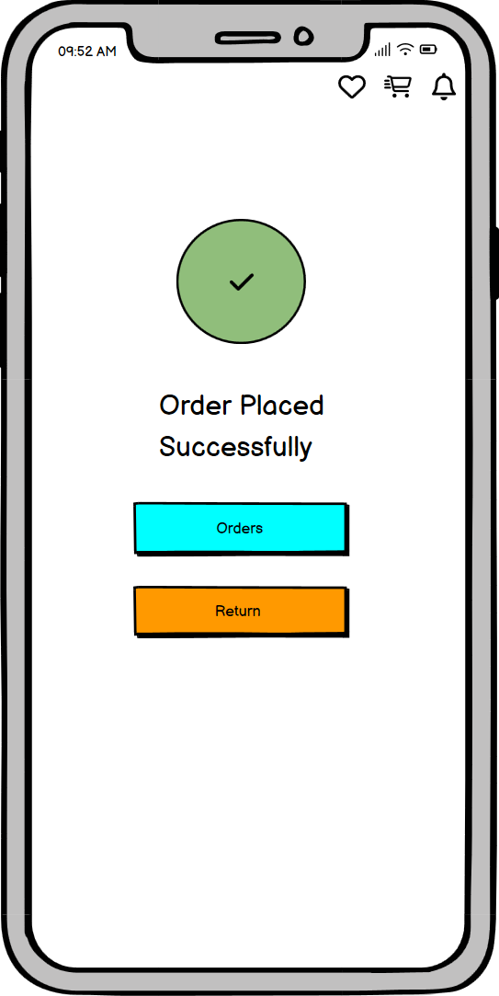
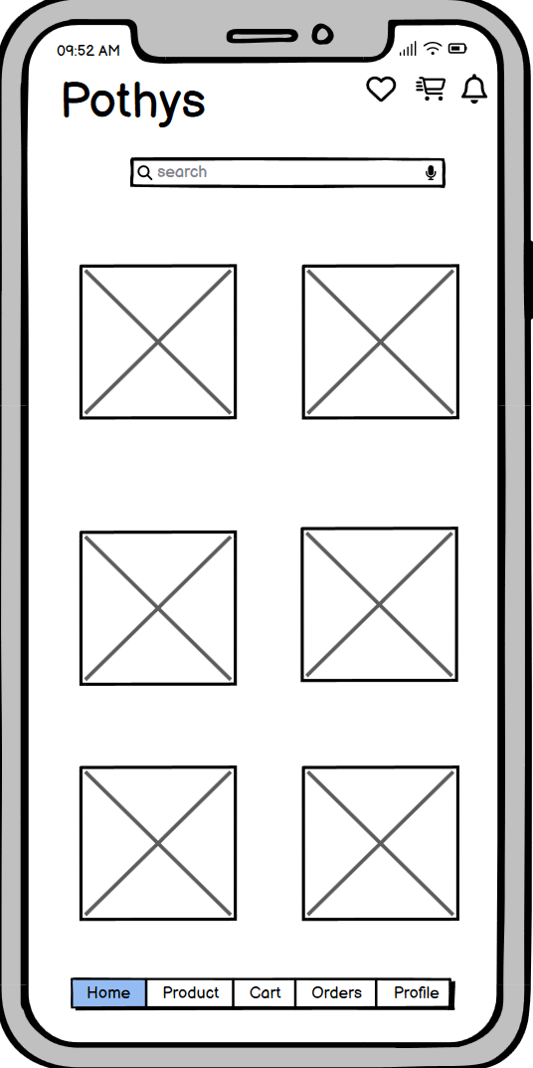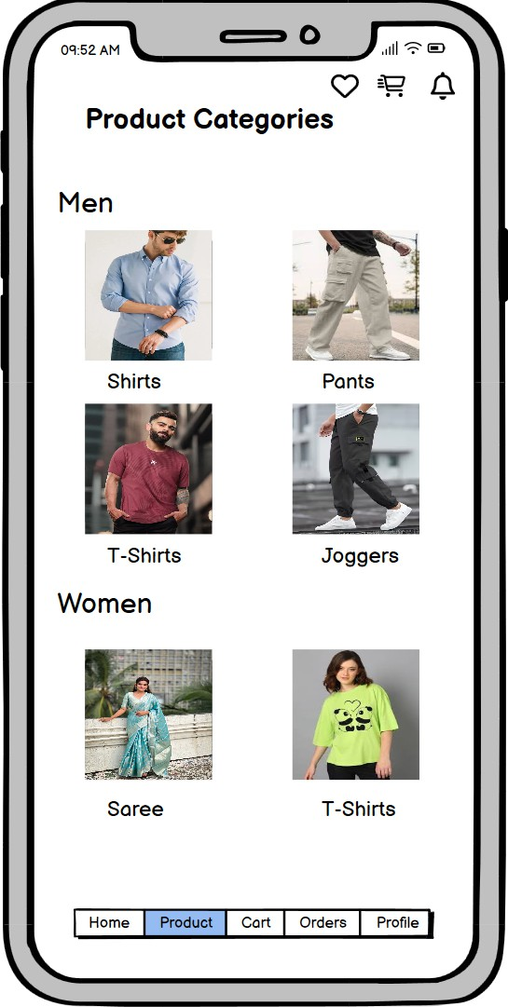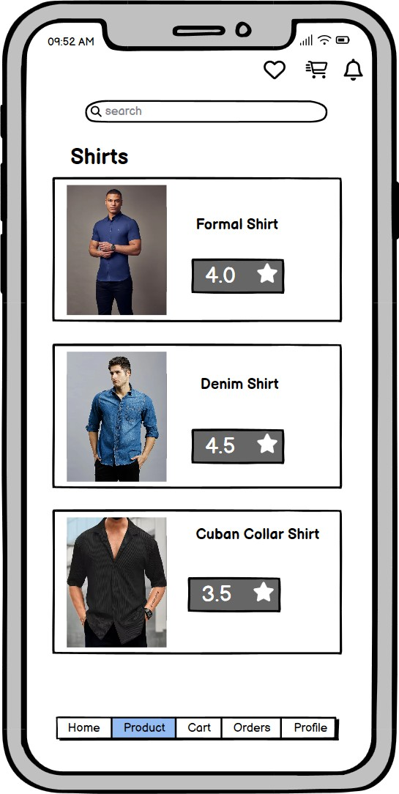

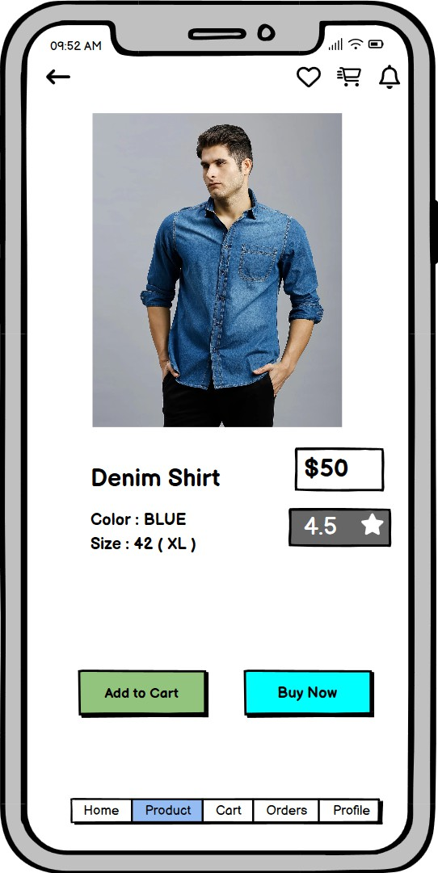
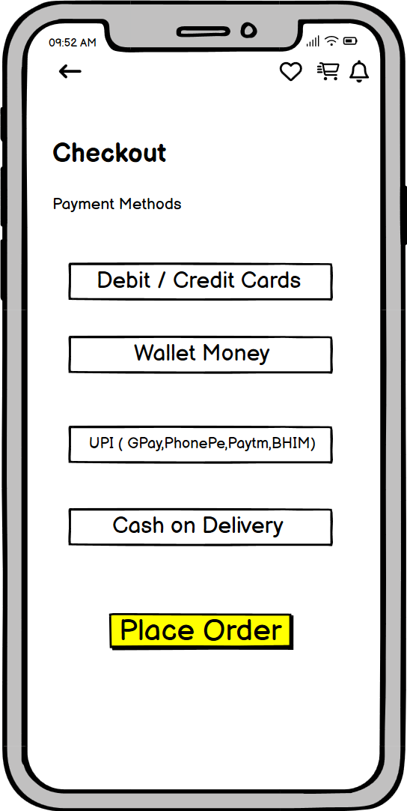

Conclusion
By including a dedicated Product Categories screen, the user flow becomes significantly more organized. This experiment demonstrates how a structured navigation system in Balsamiq helps reduce user friction, making it easier for customers to find specific products and proceed to a successful order confirmation.

